# JOBSHEET 7 OVERLOADING AND OVERRIDING

1. **Competence**

After taking this subject, students are able to:

* 1. Understand the concepts of overloading and overriding,
  2. Understand the difference between overloading and overriding,
  3. Accuracy in identifying overriding and overloading methods
  4. Accuracy in practicing instructions on the jobsheet
  5. Implement overloading and overriding methods.

# Introduction

* 1. **Overloading**

is to rewrite a method with the same name on a class. The goal is to facilitate the use/invocation of methods with similar functionality. The Overloading method declaration rules are as follows:

* + - The method name must be the same.
    - The list of parameters should be different.
    - The return type can be the same, or it can be different.

There are several lists of parameters on overloading can be seen as follows:

* + - The difference in the list of parameters does not only occur in the difference in the number of parameters, but also in the order of the parameters.
    - For example, the following two parameters:
      * Function_member (int x, string n)
      * Function_member (String n, int x)
    - The two parameters are also considered different in the list of parameters.
    - The parameter list is not related to the naming of the variables present in the parameter.
    - For example, the following 2 list of parameters:
      * function_member(int x)
      * function_member(int y)
    - The two lists of parameters above are considered the same because the only difference is the naming of the variable parameters.

Overloading can also occur between the parent class and its subclass if it meets all three overload conditions. There are several overloading rules, namely:

* + - Primitive widening conversions take precedence over overloading over boxing and var args.
    - We can't do the widening process from one wrapper type to another (changing the Integer to Long).
    - We can't do the widening process followed by boxing (from int to Long)
    - We can do boxing followed by widening (int can be an Object via an Integer)
    - We can combine var args with either widening or boxing

# Overriding

is a Subclass that seeks to modify behaviors inherited from super classes. The goal is that the subclass can have more specific behavior so that it can be done by redeclaring the parent class's method in the subclass.

The method declaration in the subclass must be the same as the one in the super class. Similarities on:

* + - Name
    - Return type (for return type: class A or is a subclass of class A)
    - List of parameters (number, type and order)

So that the method in the parent class is called the overridden method and the method in the subclass is called the overriding method. There are several method rules in overriding:

* + - The access mode of the overriding method must be the same or broader than the overridden method.
    - A subclass can only override a superclass method once, there must not be more than one method in the exact same class.
    - The overriding method must not throw checked exceptions that are not declared by the overridden method.

# Practicum

* 1. **Experiment 1**

For the following example case, there are three classes, namely Karyawan, Manager, and Staff. Employee Class is a superclass of Manager and Staff where the Manager and Staff subclasses have different methods for calculating salaries.

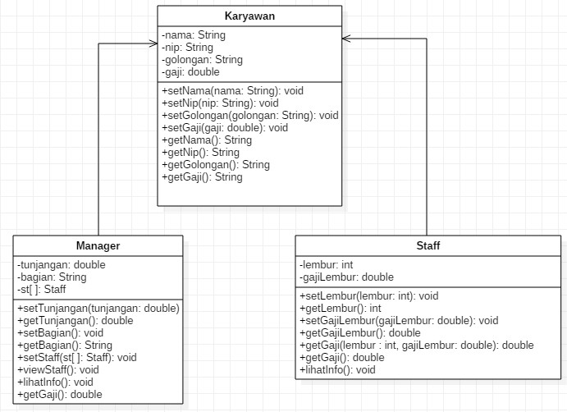

# Karyawan

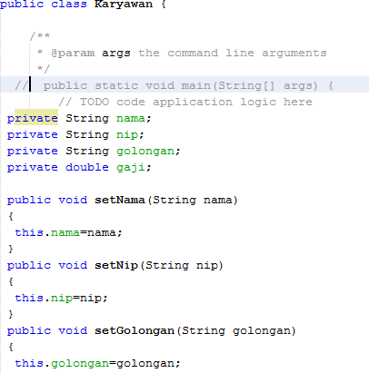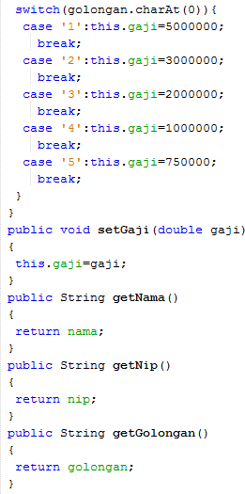

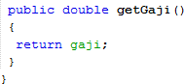

* 1. **Staff**

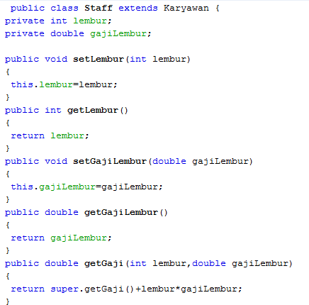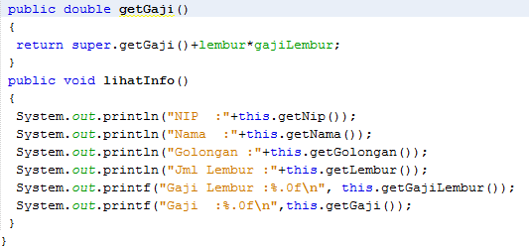

Overriding

Overloading

# Manager

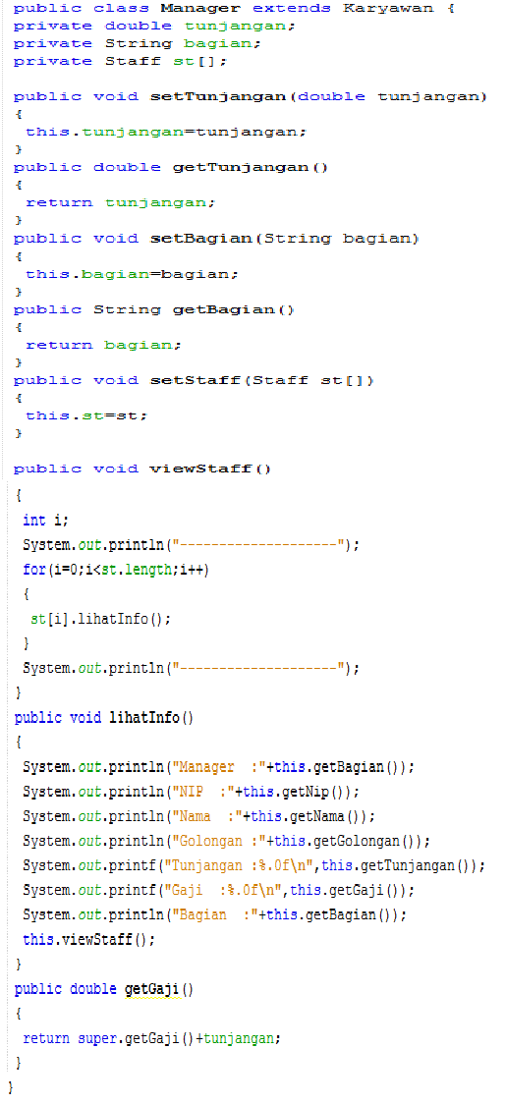

* 1. 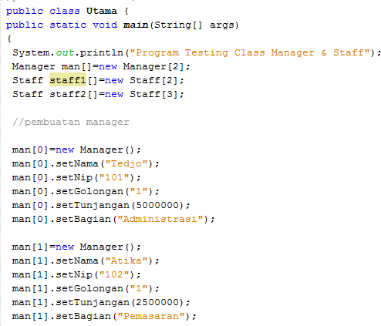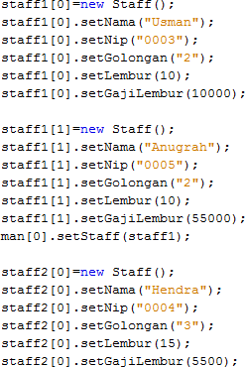**Main**

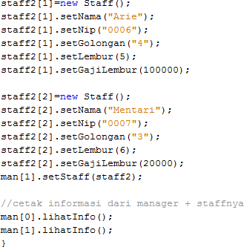

# Exercise

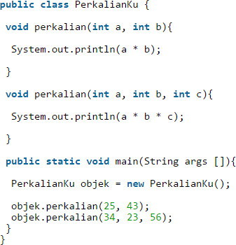

* 1. From the source coding above, where is the overloading?
* In the code the overloading is a method perkalian have a 2 parameter int a, int b and int a, int b, int C
  1. If there is overloading, how many different parameters are there?
* Have a 1 different, in method 1 have a parameter int a, and b. meanwhile in the method 2 have a parameter int a, b, and c

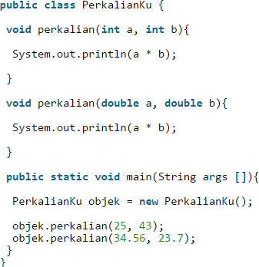

* 1. From the source coding above, where is the overloading?
* In the code the overloading is a method ‘perkalian’. In this case have a 2 same method that called a **Overloading**
  1. If there is overloading, how many different types of parameters are there?
* Have a 1 different, in the method ‘perkalian’ one, have parameter int all of them and in the method ‘perkalian’ two have a parameter double all of them

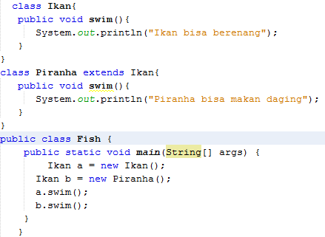

* 1. From the source coding above, where is the overriding?
* In the class Piranha extends Ikan
  1. Describe when sourcoding above if there is overriding?
* Because the name method is same and become in subclass from superclass

# Tasks

* 1. **Overloading**

Implement the overloading concept in the diagram class below:

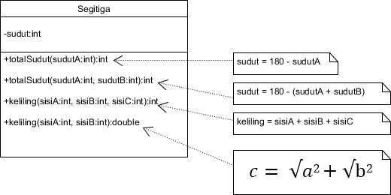

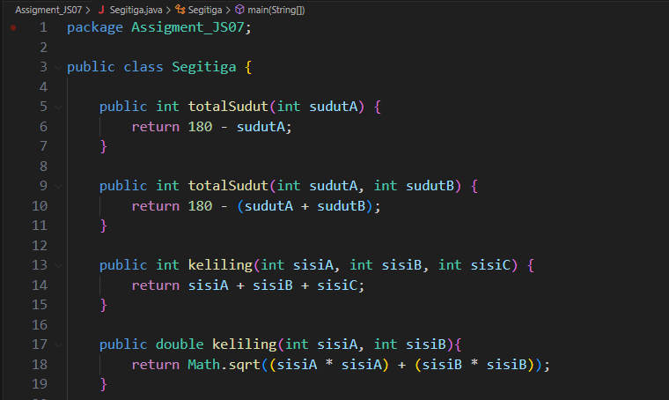

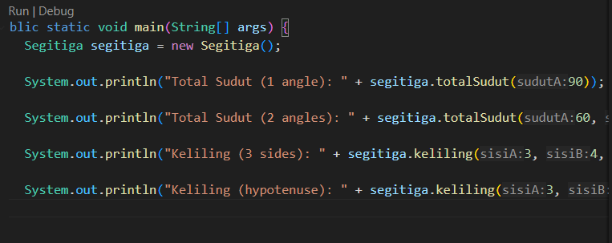

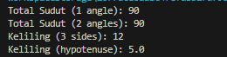

# Overriding

Implement the diagram class below using the dynamic method dispatch technique:

